# Creative Making:

# Advanced Visualisation and Computational Environments Final Project

PLAN：

Sense：Outdoor --- In the valley

Object： mountain，tree，RV，The bonfire，lake，player

The weather：day&night；rainy&sunny

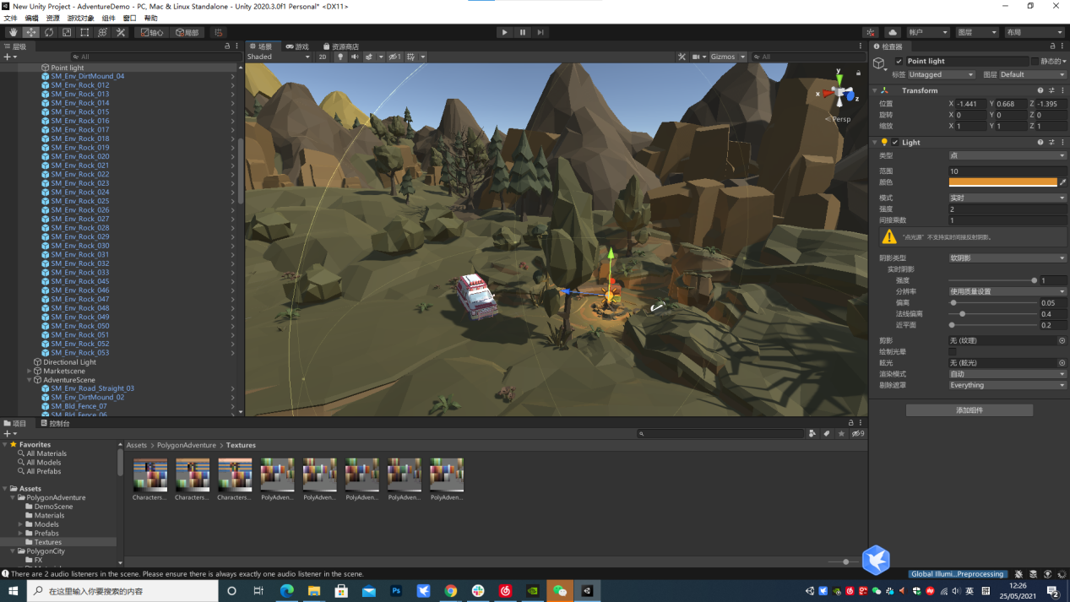

This is an outdoor life experience game.The background of the game is an Asian Internet company's staff, he is tired of 14 hours a day of high intensity work, so quit his job and drive his own RV to nature to find the happiness of childhood, let himself relax.

The game uses Lowpoly's graphic style to give it a softer look.

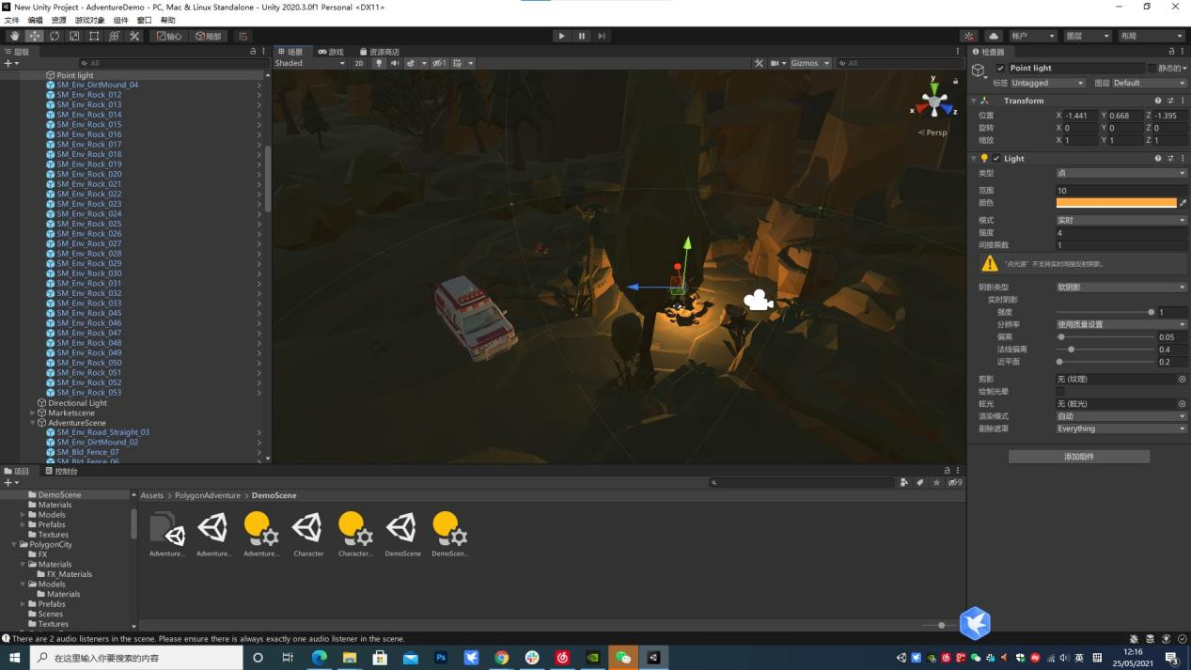

## FINAL：

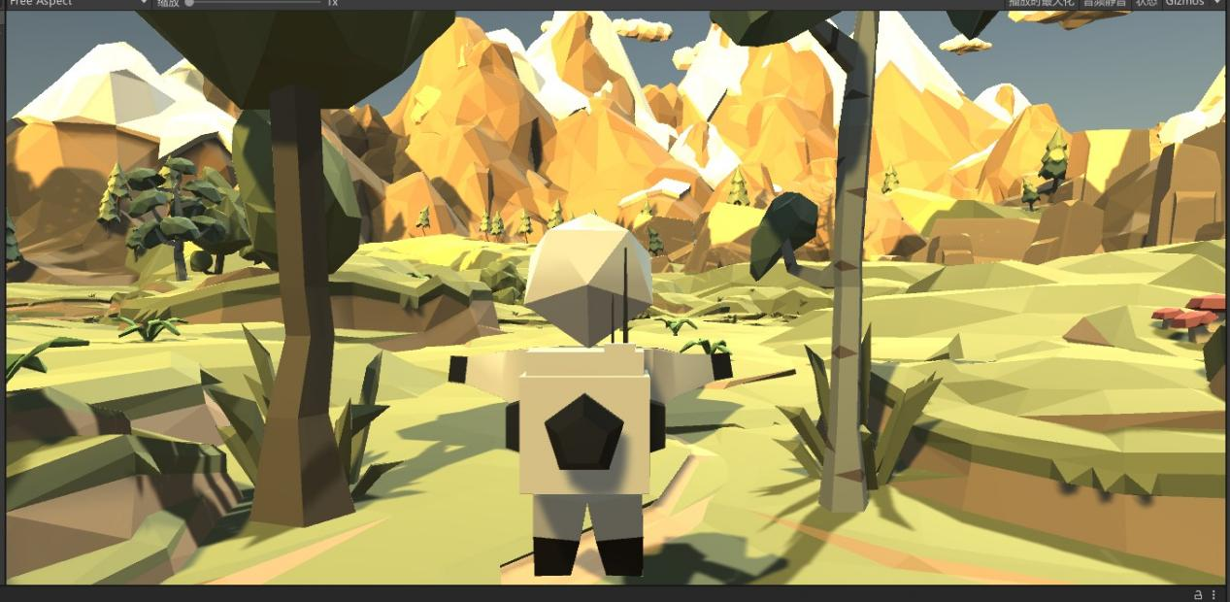

Operational guidelines

W - front

S - back

A - turn left

D - turn right